Quality Management Policy

Introduction
Mercy Hands goal is to deliver its services and products to the beneficiaries in the right time and quantities and the highest quality. Mercy Hands adopts quality management approach to achieve excellence in its services and products. Quality management has four main components: quality planning, quality assurance, quality control and quality improvement. These four components complement each other, and they represent a continuous process that must be followed in order to achieve excellence in our services and products.

Quality Assurance Vs Quality Control
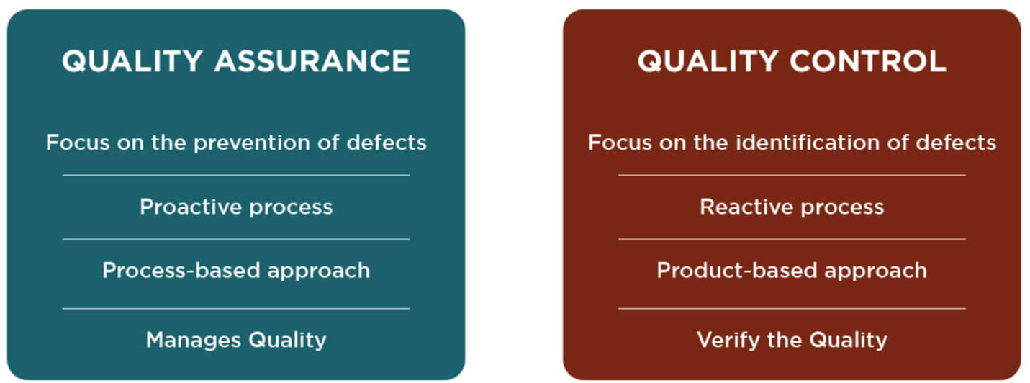

Quality Assurance is different to routine monitoring in that it focuses on comparisons the quality of actual outputs to the descriptions of deliverables as opposed to measurements of established program indicators

in 2022 Mercy Hands established the Quality Management Division to be responsible for the quality management of Mercy Hands’ programs, products, and services. Quality Management Division is one of the administrative branches of Monitoring, Evaluation, Accountability, and Learning (MEAL) Department.

Responsibility
It is the responsibility of the MEAL Director to always ensure the proper application of Quality Management policy and procedures within all Mercy Hands programs. MEAL Director is responsible for designing, applying, and developing quality management tools and procedures.

When possible, MEAL Officers will be assigned to Mercy Hands programs to assist the MEAL Director in applying quality management procedures for their programs.

Guidelines

- Descriptions of individual program deliverables form the basis for quality management. As part of any program planning, the program manager develops a clear description of the program deliverables and share it with the MEAL Director for review and approval before submitting the program proposal to the donor.
Examples of descriptions of deliverables include:
  - Training agendas, materials, and facilitators’ notes for trainings
  - Design drawings and Bill of Quantities for infrastructure
  - Scope of Work or Terms of Reference for technical consultancies
  - Approach and process documentation (for example, a community mobilization process, or nutrition rehabilitation process, or a farmers’ capacity building process)
- If a program proposal is being considered for funding, the MEAL Director must develop the quality assurance plan for the program and have it ready prior to the launch of the program. The quality assurance plan must include the quality assurance checklist and frequency of quality assurance reporting.
- Quality assurance checks are carried out at least twice per program year. Reports of quality assurance checks must be one of the project’s deliverables. Like M&E, the quality assurance check must be carried out by a non-program staff, either a MEAL Officer or someone temporarily assigned by the MEAL Director, or the MEAL Director herself.
An example of what is described above is summarized in the table below:

Deliverables | 1,000 latrines
Description of Deliverables | Standard latrine drawing and Bill of Quantities
Quality Assurance Checks | Visits during and after construction to confirm the total number of latrines (physical verification), and the actual design of the latrines as compared to the planned design within the description of deliverables

- During quality assurance checks, actual deliverables should be checked against planned descriptions of deliverables, and any discrepancies should be reported to the MEAL Director who in turn will report to the Executive Administration so that corrective action (quality control), if required, can be taken.
- For quality improvement, the MEAL Director shall document lessons learned from quality assurance checks and apply them for future similar programs.

Reviewed and approved by:

Khaldoon Al-Moosawi
Executive Director
November 1, 2022

